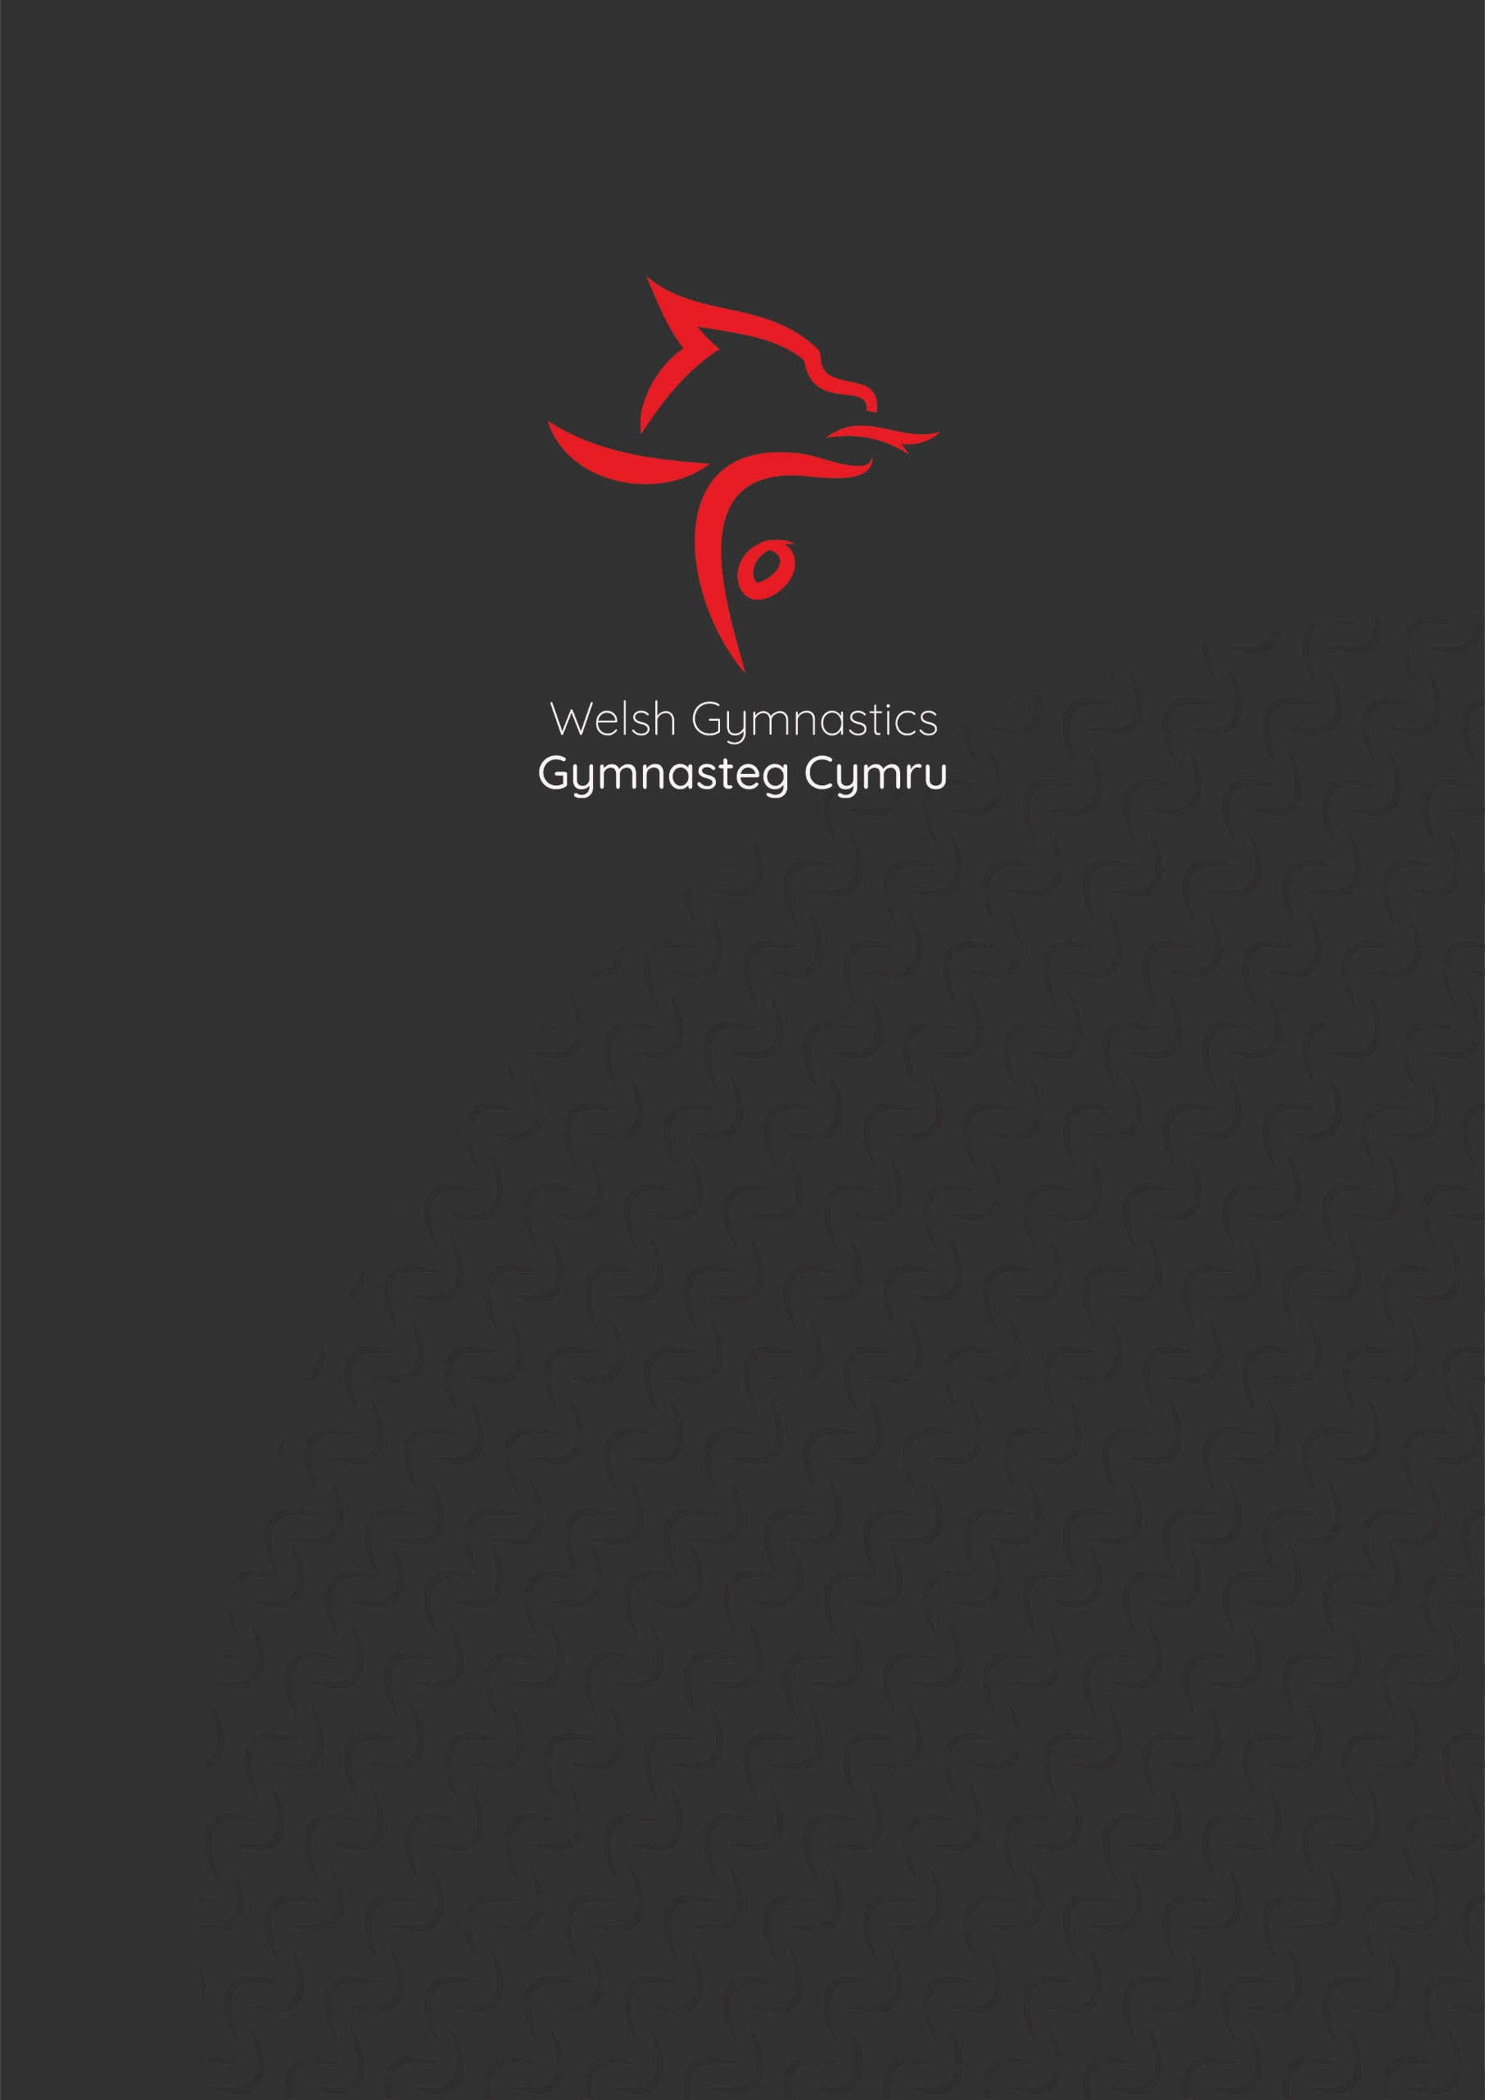

RHYTHMIC SPRING STARS
Llandarcy Sports Academy NEATH
Llandarcy Park
NEATH
SA10 6JD

Doors Open at 8am

Welcome to
Rhythmic Spring Stars 2024

On behalf of Welsh Gymnastics,
We would like to thank all the gymnasts, volunteers, coaches, judges, and everyone involved in the event today. Without you it would not have been possible.

Please be mindful of parking restriction at the venue:
Note from the Venue:

Due to the volume of people attending the facility on Saturday April 27th, ie., other bookings, birthday parties etc, the spectators attending the gymnastics competition will need to pay to park, this will be on a first come first served basis.
Costings to park are £1.05 per hour.
LLandarcy Park will accept no responsibility for individuals who have failed to adhere to the parking restrictions clearly signposted on site.
Look forward to receiving the running order of the day.

Saturday
Spring Stars Cup 2024
Llandarcy Academy of Sport - Saturday 27th April
Start List/Timings
Warm Up - 8.30am
Group Orientation - 9.30-9.34am Llanelli Sapphires
9.34-9.38am Llanelli Diamonds
9.38-9.43am Llanelli Emeralds
9.43-9.48am Olivia's Juniors
9.48-9.53am Llanelli Dragons
Individual Orientation - 9.53-9.57am Open Carpet For All Level 0 Gymnasts
March On Level 0 & Group Gymnasts - 10.05am
Competition Starts 10.10am
CC | Dragons |  | Espoir | Level 5 | Hoop | CC
1 | Llanelli Sapphires | Llanelli RGA | Espoir | Level 2 | Hoop
2 | Llanelli Diamonds | Llanelli RGA | Espoir | Level 2 | Hoop
3 | Llanelli Emeralds | Llanelli RGA | Junior | Level 2 | Hoop
4 | Olivia's School of RG | Olivia's School of RG | Junior | Level 3 | Hoop
CC | Dragons |  | Espoir | Level 5 | Free | CC
5 | Marcie Morgan | Llanelli RGA | U6 | Level 0 | Free
6 | Darcy-Rose Curran | Llanelli RGA | U7 | Level 0 | Free
7 | Ellsie Morgan | Llanelli RGA | U8 | Level 0 | Free
8 | Kaia Smith | Llanelli RGA | U10 | Level 0 | Free
CC | Dragons |  | U10 | L5 | Free | CC
1 | Llanelli Sapphires | Llanelli RGA | Espoir | Level 2 | Hoop
2 | Llanelli Diamonds | Llanelli RGA | Espoir | Level 2 | Hoop
3 | Llanelli Emeralds | Llanelli RGA | Junior | Level 2 | Hoop
4 | Olivia's School of RG | Olivia's School of RG | Junior | Level 3 | Hoop
CC | Anastasiia Hladka |  | U10 | Level 5 | Hoop | CC
9 | Ellie Taylor | Planet Sport and Community | U12 | Level 0 | Free
10 | Shantelle Brooks | Llanelli RGA | U12 | Level 0 | Free
11 | Victoria Burchell | Planet Sport and Community | U12 | Level 0 | Free
12 | Eva-Lily Davies | Llanelli RGA | U12 | Level 0 | Free
13 | Maisey Wright | Llanelli RGA | O12 | Level 0 | Hoop
CC | Harper Davies |  | U11 | L4 | Hoop | CC
Break 11.05-11.20am
Presentations -11.05-11.15am - Level 0 & Group Gymnasts
Orientation Level 1 - 11.15-11.20am - Free Open Carpet for All Level 1 Gymnasts
March On Level 1 Gymnasts - 11.22am
Re-Start Competition - 11.25am
CC | Anastasiia Hladka |  | U10 | L5 |  | CC
14 | Daisie Robinson | Olivia's School of RG | U8 | Level 1 | Free
15 | Matilda Mason | Llanelli RGA | U8 | Level 1 | Free
16 | Molly Bird | Llanelli RGA | U8 | Level 1 | Free
17 | Evie Graves | Llanelli RGA | U8 | Level 1 | Free
CC | Esme Jenkins |  | U10 | L5 |  | CC
18 | Darcie Woolcock | Olivia's School of RG | U10 | Level 1 | Free
19 | Ela Fflur Evans | Planet Sport and Community | U10 | Level 1 | Free
20 | Amelia Thompson | Olivia's School of RG | U10 | Level 1 | Free
21 | Harriett Davies | Llanelli RGA | U10 | Level 1 | Free
22 | Darcy-May Llewellyn | Olivia's School of RG | U10 | Level 1 | Free
23 | Rhea Milward | Olivia's School of RG | U10 | Level 1 | Free
24 | Megan Lewis | Olivia's School of RG | U10 | Level 1 | Free
CC | Harper Davies |  | U11 | L4 | Clubs | CC
25 | Chloe Gulwell-Jones | Planet Sport and Community | U12 | Level 1 | Hoop
26 | Yana Zavalniuk | Planet Sport and Community | U12 | Level 1 | Hoop
27 | Danika Clarke | Llanelli RGA | U12 | Level 1 | Hoop
28 | Sophia Howells | Llanelli RGA | U12 | Level 1 | Hoop
29 | Evie Staples | Llanelli RGA | U12 | Level 1 | Hoop
30 | Layla Rees | Olivia's School of RG | U12 | Level 1 | Hoop
31 | Skyla Smith | Llanelli RGA | U12 | Level 1 | Hoop
32 | Poppy Valentine | Llanelli RGA | U12 | Level 1 | Hoop
CC | Esme Jenkins |  | U10 | L5 |  | CC
33 | Ella Woolcock | Olivia's School of RG | U13 | Level 1 | Ball
34 | Brooke Whalley | Olivia's School of RG | U13 | Level 1 | Ball
35 | Tsz Ching Hui | Planet Sport and Community | Junior | Level 1 | Ball
CC | Ella-Rose Thomas |  | U11 | L5 |  | CC
Break 12.25-12.45pm
Orientation - 12.25-12.30pm - Free Open Carpet for All Level 2 Gymnasts
March On Level 2 Gymnasts - 12.35pm
Re-Start Competition - 12.40pm
CC | Ella-Rose Thomas |  | U11 | L5 |  | CC
36 | Erin Goddard | Olivia's School of RG | Senior | Level 2 | Ball
37 | Lacey Robinson-Goddard | Olivia's School of RG | Junior | Level 2 | Ball
CC | Eleni Spear |  | Junior | L5 |  | CC
38 | Fraya-Ella Richards | Olivia's School of RG | U13 | Level 2 | Ball
39 | Lily Toft | Llanelli RGA | U13 | Level 2 | Ball
40 | Layla-Grace Evans | Olivia's School of RG | U13 | Level 2 | Ball
41 | Ebonnie Pearce | Llanelli RGA | U13 | Level 2 | Ball
42 | Ella-Rae Davies | Olivia's School of RG | U13 | Level 2 | Ball
CC | Liliana Evans |  | U9 | L5 |  | CC
43 | Fraya White | Llanelli RGA | U12 | Level 2 | Free
44 | Lacie Mann | Llanelli RGA | U12 | Level 2 | Free
45 | Phoebe Brookfield | Llanelli RGA | U12 | Level 2 | Free
CC | Bonnie Williams |  | U12 | L5 |  | CC
46 | Grace Hall | Llanelli RGA | U10 | Level 2 | Free
47 | Talliah Beookes | Llanelli RGA | U10 | Level 2 | Free
48 | Darcie Norman | Olivia's School of RG | U10 | Level 2 | Free
49 | Kelsey Costa | Llanelli RGA | U10 | Level 2 | Free
50 | Leila-Reece Hooper | Olivia's School of RG | U10 | Level 2 | Free
CC | Wiktoria Barczewska |  | Junior | L5 |  | CC
51 | Georgia Torkingtom | Llanelli RGA | U8 | Level 2 | Free
52 | Rhianedd Nicholas | Llanelli RGA | U8 | Level 2 | Free
53 | Alica Hall | Llanelli RGA | U8 | Level 2 | Free
54 | Emilia Zielinska | Llanelli RGA | U8 | Level 2 | Free
CC | Liliana Evans |  | U9 | L5 |  | CC
CC | Amelie Haines |  | Junior | L5 |  | CC
36 | Erin Goddard | Olivia's School of RG | Senior | Level 2 | Ribbon
37 | Lacey Robinson-Goddard | Olivia's School of RG | Junior | Level 2 | Clubs
CC | Bonnie Williams |  | U12 | L5 |  | CC
38 | Fraya-Ella Richards | Olivia's School of RG | U13 | Level 2 | Clubs
39 | Lily Toft | Llanelli RGA | U13 | Level 2 | Clubs
40 | Layla-Grace Evans | Olivia's School of RG | U13 | Level 2 | Clubs
41 | Ebonnie Pearce | Llanelli RGA | U13 | Level 2 | Clubs
42 | Ella-Rae Davies | Olivia's School of RG | U13 | Level 2 | Clubs
CC | Athena Chan |  | U12 | L5 |  | CC
CC | Mali Lane |  | Senior | L4 |  | CC
43 | Fraya White | Llanelli RGA | U12 | Level 2 | Hoop
44 | Lacie Mann | Llanelli RGA | U12 | Level 2 | Hoop
45 | Phoebe Brookfield | Llanelli RGA | U12 | Level 2 | Hoop
CC | Imogen Coslett |  | U13 | L5 |  | CC
46 | Grace Hall | Llanelli RGA | U10 | Level 2 | Ball
47 | Talliah Brookes | Llanelli RGA | U10 | Level 2 | Ball
48 | Darcie Norman | Olivia's School of RG | U10 | Level 2 | Ball
49 | Kelsey Costa | Llanelli RGA | U10 | Level 2 | Ball
50 | Leila-Reece Hooper | Olivia's School of RG | U10 | Level 2 | Ball
CC | Tabitha Rigg |  | U13 | L5 |  | CC
Break - 2.20-2.45pm
Orientation - 2.20-2.25pm - Free Open Carpet for All Level 3 Gymnasts
March On Level 3 Gymnasts - 2.30pm
Re-Start Competition 2.35pm
CC | Eleni Spear |  | Junior | L5 |  | CC
55 | Victoria Giardelli | Olivia's School of RG | Senior | Level 3 | Hoop
56 | Kiera Davies | Llanelli RGA | Junior | Level 3 | Hoop
57 | Sophia Tilley | Llanelli RGA | Junior | Level 3 | Hoop
58 | Lexie Norman | Olivia's School of RG | Junior | Level 3 | Hoop
59 | Lowri Hudson | Llanelli RGA | Junior | Level 3 | Hoop
60 | Teleri Williams | Llanelli RGA | U12 | Level 3 | Hoop
CC | Athena Chan |  | U12 | L5 |  | CC
61 | Felicity Jones | Llanelli RGA | U8 | Level 3 | Free
62 | Robyn Watson | Llanelli RGA | U8 | Level 3 | Free
63 | Gracie Thomas | Llanelli RGA | U8 | Level 3 | Free
CC | Imogen Coslett |  | U13 | L5 |  | CC
55 | Victoria Giardelli | Olivia's School of RG | Senior | Level 3 | Ball
56 | Kiera Davies | Llanelli RGA | Junior | Level 3 | Ball
57 | Lexie Norman | Olivia's School of RG | Junior | Level 3 | Ball
58 | Lowri Hudson | Llanelli RGA | Junior | Level 3 | Ball
59 | Teleri Williams | Llanelli RGA | U12 | Level 3 | Clubs
CC | Tabitha Rigg |  | U13 | L5 |  | CC
CC | Wiktoria Barczewska |  | Junior | L5 |  | CC
60 | Felicity Jones | Llanelli RGA | U8 | Level 3 | Hoop
61 | Robyn Watson | Llanelli RGA | U8 | Level 3 | Hoop
62 | Gracie Thomas | Llanelli RGA | U8 | Level 3 | Hoop
CC | Amelie Haines |  | Junior | L5 |  | CC
55 | Victoria Giardelli | Olivia's School of RG | Senior | Level 3 | Ribbon
56 | Kiera Davies | Llanelli RGA | Junior | Level 3 | Clubs
57 | Sophia Tilley | Llanelli RGA | Junior | Level 3 | Clubs
58 | Lexie Norman | Olivia's School of RG | Junior | Level 3 | Clubs
59 | Lowri Hudson | Llanelli RGA | Junior | Level 3 | Clubs
CC | Mali Lane |  | Senior | L4 |  | CC
Competition Ends - 3.20pm
Presentations 3.25pm

Photography Regulations

In order to protect the welfare of children at the event, photography at this event is permitted only on conditions set by Welsh Gymnastics and British Gymnastics.
This is a summary of those conditions. A copy of the full text can be obtained from the Competition Organiser or from the British Gymnastics website www.british-gymnastics.org. If you do not agree to these conditions you may not bring any photo equipment into the venue or take any photos. ‘Photo’s’ includes any form of video or still image including those taken with mobile phones.
- The Competition Organiser (or a person acting on his or her authority) may require anyone at the event:
- Not to take photos either generally or in particular circumstances.
- To provide their full name and address and evidence of this
- To let the Competition Organiser, view any images recorded and to delete any images.
- To surrender media or equipment on which the images have been recorded if they cannot be viewed (e.g. photos on traditional film), or if they cannot be deleted.
- Photos may only be taken and used in accordance with the British Gymnastics Child Protection Policy.
- Photos may not be used, distributed or copied for commercial purposes.
- Flash may not be used at any time while gymnasts are warming up or competing.
*Taken from Appendix 2 British Gymnastics Conditions for Audience Photography at Gymnastic Events Short Form – BG Photography Regulations.
Competition Officials
Judges Meeting | 9.45am
Nia Evans
Rachel Haines
Eirian Thomas
Volunteers
Stephanie Hudson | Door
Kirstin Jenkins | Announcer/Scorer
Lyndsey Spear | Music/Scorer
Maria Gaynor | Marshall
Seren Coslett | Safeguarding & Welfare Officer

