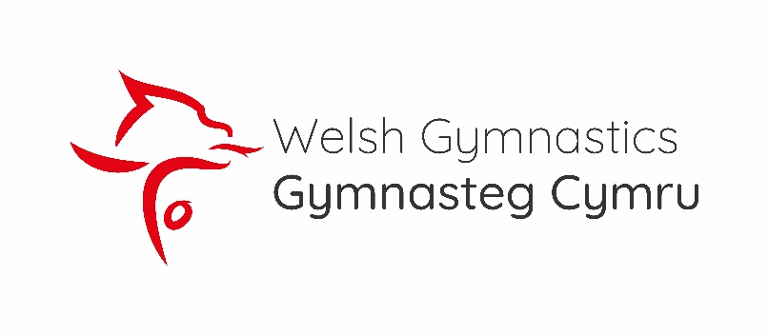

**INCLUSIVE TRAMPOLINE ROUTINES**

**Criteria**

* + - * + Elite
        + Novice

**DISABILITY**

Disability Trampoline Category 1 and Category 2 gymnasts are invited to these Championships in the age groups YOUTH (9-12), JUNIOR (13-16yrs) SENIOR (17pus)

Please enter using the Entry Form indicating Cat 1 or Cat 2 in the Age Group column. There will be separate awards for Category 1 and Category 2 gymnasts in all Disability Levels.

|  |  |
| --- | --- |
| **Disability Elite Routine** | |
| **First Routine Requirements** | **Second Routine Requirements** |
| 10 Contact Routine | 10 Contact Routine |
| Must include a 360 Degree Twist | Repeated moves will not be credited with a difficulty score |
| Two separate body landings, both with 180o twist into or out of the move | Minimum Difficulty of 3.0 No Maximum Difficulty |
| Moves and shapes CANNOT be repeated | If the minimum tariff is not achieved 1.0 marks will be deducted per judge |
| **Disability Novice Routine** | |
| **First Routine Requirements** | **Second Routine Requirements** |
| 10 Contact Routine | 10 Contact Routine |
| Moves and shapes CAN be repeated | Repeated moves will not be credited with a difficulty score |
|  | NO Minimum difficulty |
|  | Maximum Difficulty of 2.9 |

One small change for the Disability Novice first routine: skills can only be repeated once. The TP would like to encourage using different skills.